Annex Q: Protected Areas within the Project Landscapes and Proposed New Protected Areas

CONTENTS
Existing Protected Area Network within the Managing Together Project Landscape 2
Types of protected areas and their jurisdiction 2
Protected Area Coverage within the landscape/seascape 6
Protected areas under the management of the Forest Department 6
Protected areas under the management of the Department of Wildlife Conservation 6
Other PAs within the project landscape 6
Protected Area Coverage within the Trial Landscape 1 7
Protected Area Coverage within the Trial Landscape 2 8
Protected Area Coverage within the Trial Landscape 3 8
Proposed and potentially new protected areas and elephant corridors 10
Potentially new PAs and areas to be augmented to the existing PAs 10
Proposed Elephant Corridores 11
Overall plan for elephant corridors in the northern region of Sri Lanka 12
Dugong and Seagrass Conservation Areas 14
Contribution of proposed PAs within the project landscape and designated Trial Landscapes 14
Ecologically Sensitive Areas 16
Existing Protected Area network management plans and their effectiveness 16
References 16

Existing Protected Area Network within the Managing Together Project Landscape

Types of protected areas and their jurisdiction
As explained under the section on National Context, main authorities of the Ptotceted Area (PA) netowrk of Sri Lanka, and hence the project landscape are the Department of Wilidlife Conservation (DWC) and the Forest Department (FD), respectively under the jurusdiction of the Fauna and Flora Protection Ordinance (FFPO) and the Forest Conservation Ordinace (FCO) (MoMD&E, 2016). Additionally a single management area declaired under the Fisheries and Aquatic Resources Act is relevant to the seascape, while Environmental Protected Areas (EPA) under the National Environmental Act are irrelevant to both the project landscape and the seascape. Four Important Bird Areas (out of 70 in Sri Lanka) are also situated within the project landscape but they are not managed/regulated under any jurisdiction. The Table. 1 given below listst the Protected Area categories relevant to the project landscae as well as the seascape, with the level of protecetion in breif, while the Figure. 1 maps all the Proteceted Areas within the project landscape.
In addititon to the above protected areas, the Forest Department also manages several production forests within the project landscape, in order to cater the national timber demands, i.e. Forest Plantations, mainly comprised of monocultures of Teak (Tectona grandis) within the project landscape.

Table 1. Protected areas within the ‘Managing Together’ (‘MT’) project landscape and the seascape together with their management details
Authority | Jurisdiction | National PA Category | Level of Protection
Department of Wilidlife Conservation | Fauna and Flora Protection Ordinance | Strict Nature Reserve | Fully proteceted, no one can enter, state land
Department of Wilidlife Conservation | Fauna and Flora Protection Ordinance | National Park | High level of protecetion, tourism allowed, state land
Department of Wilidlife Conservation | Fauna and Flora Protection Ordinance | Sanctuary | Low level of protecetion, management regulations, state and private land
Department of Wilidlife Conservation | Fauna and Flora Protection Ordinance | Marine Nature Reserve | High level of protecetion, research allowed, state ownership
Department of Wilidlife Conservation | Fauna and Flora Protection Ordinance | Marine National Park | High level of protecetion, tourism allowed, state ownership
Department of Wilidlife Conservation | Fauna and Flora Protection Ordinance | Marine Scanctuary | Low level of protecetion, managem-ent regulations, state ownership
Forest Department | Forest Conservation Ordinace | Conservation Forests | High level of protecetion, state land
Forest Department | Forest Conservation Ordinace | Reserved Forests | Moderate level of protecetion, state land
Coast Conservation and Coastal Resou-rces Management Department | Fisheries and Aquatic Resources Act | Fisheries Management Areas | For management regulations on fishries related activity
Birdlife International | None | Important Bird Areas | No management, just an identification by the Field Ornithology Group of Sri Lanka (FOGSL). No area polygon demarcation even on a map.

Table 2. given below provides a summary of all PAs within the project lanndascpe including their numbers and the area covered by them, while the Figure 1 maps all the PAs summarised in the table 2 with different colours for different PA categories, except for Fisheries Management Areas and the Important Bird Areas. Please see the Table 3 for detailes of individual protected areas within the landscape and the seascape, reffered to numbers provided in Figure 1.

Table 2. Protected area summary of the project landscape (all areas given in Km²)
Area of the overall project landscape |  |  |  | 5942.14
Area of the project seascape |  |  |  | 874.81
 |  | Number | Total Area | % of overall landscape
Existing Protected Areas |  | 35 | 2083.20 | 35.06
Total under the jurisdiction of the Forest Department |  | 26 | 655.77 | 11.04
 | Conservation Forest | 3 | 354.81 | 5.97
 | Reserved Forest | 17 | 222.66 | 3.75
 | Forest Plantation | 6 | 78.30 | 1.32
Total under the jurisdiction of the Department of Wildlife Conservation - on the landscape |  | 9 | 1427.43 | 24.02
 | Strict Nature Reserve | 1 | 13.00 | 0.22
 | National Park | 2 | 1275.59 | 21.47
 | Sanctuary | 6 | 138.84 | 2.34
 |  | Number | Total Area
Proposed Protected Areas |  | 5 | 602.91
 |  | Number | Total Area | % of overall landscape
 | Elephant corridors | 3 | 138.24 | 2.33
 |  | Number | Total Area | % of seascape
 | Dugong & seagrass conservation areas | 2 | 464.67 | 53.12
 | Potential Ecologically Sensitive Areas | To be decided based on a detailed biodiversity assessment in three Trial Landscapes

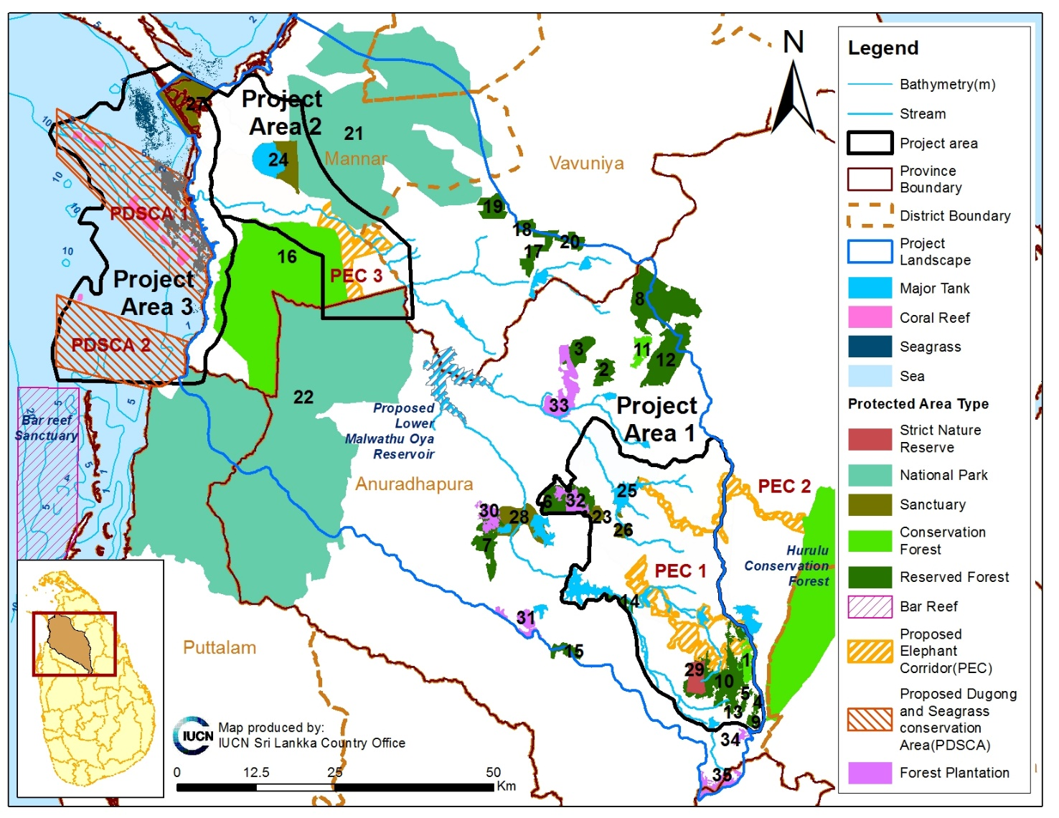
Figure 1. All protected areas and forest plantations within the project landscape provided with numbers that refer to Table 2 for details. Only those protected areas outside the project landscape and the proposed lower Malwathu Oya reservoir are labelled.

Table 3. Details of protected areas and forest plantations mapped in the Figure 1 within the project landscape
No | Type | Name | Area (km²)
1 | Conservation Forest | Galapitagala CF | 9.31
2 | Reserved Forest | Hinna RF | 10.88
3 | Reserved Forest | Isinbessagala RF | 12.84
4 | Reserved Forest | Kumbukwewa RF | 2.57
5 | Reserved Forest | Mahadiulwewa RF | 1.53
6 | Reserved Forest | Mihintale RF | 20.92
7 | Reserved Forest | Nuwaragam RF | 18.38
8 | Reserved Forest | Padawiya RF | 28.00
9 | Reserved Forest | Palugasyaya RF | 2.86
10 | Reserved Forest | Ritigala RF | 46.92
11 | Conservation Forest | Semawa CF | 9.32
12 | Reserved Forest | Wedakanda RF | 34.16
13 | Reserved Forest | Weeragala RF | 1.97
14 | Reserved Forest | Wembukulama RF | 4.87
15 | Reserved Forest | Yoda Ela RF | 4.47
16 | Conservation Forest | Mavillu CF | 336.17
17 | Reserved Forest | Irasenthirankulam RF | 13.22
18 | Reserved Forest | Puwarasankulam RF | 1.49
19 | Reserved Forest | Puwarasankulam RF | 13.98
20 | Reserved Forest | Tonigala RF | 3.59
21 | National Park | Madhu Road NP | 594.99
22 | National Park | Wilpattu NP | 680.60
23 | Sanctuary | Anuradhapura S | 5.62
24 | Sanctuary | Giant's tank S | 40.29
25 | Sanctuary | Mahakandarawa S | 12.41
26 | Sanctuary | Mihintale S | 5.33
27 | Sanctuary | Vankalai S | 40.92
28 | Sanctuary | Nuwaragam S | 34.26
29 | Strict Nature Reserve | Ritigala SNR | 13.00
30 | Forest Plantation | Anuradhapura FP | 10.30
31 | Forest Plantation | Batueathth FP | 10.71
32 | Forest Plantation | Mihintale FP | 12.19
33 | Forest Plantation | Poonewa FP | 29.31
34 | Forest Plantation | Tumbikulama FP | 3.17
35 | Forest Plantation | Murungahitikanda FP | 12.61
Proposed Protected Areas
Proposed Elephant Corridor 1 |  |  | 64.42
Proposed Elephant Corridor 2 |  |  | 18.74
Proposed Elephant Corridor 3 |  |  | 55.08
Proposed Dugong & Seagrass Conservation Area 1 |  |  | 276.62
Proposed Dugong & Seagrass Conservation Area 2 |  |  | 188.05

Protected Area Coverage within the landscape/seascape
The total area of the project landscape is 5942km², while a remarkable 35% of the landscape (2083km²) is protected either under the DWC or FD (see Table 42. for details on each PA type). While the larger National Parks of Wilpattu and Madu-Raod are mainly responsible for this percentage, it should also be noted that most of the other PAs in the ‘elephant country’ (e.g. Trial Landscape1) are smaller and fragmented.
The total seascape of the Trial Landscape, i.e. the marine section of the Trial Landscape 3 is 875km² (The Trial Landscapes 3 beeing 1056km² in size, 181km² to is taken by the coastal strip of approximately 3km wide from Vankalai, to Kondachchi via Arippu and Silavaturai. Nevertehless, as of now no marine PA exists within the limits of the Trial Landscape 3.

Protected areas under the management of the Forest Department
The total area protected under the FD acounts for 656km², which is 11% of the landscape. Among them only 355km² (which is 6% are conservation forests) provides a higher level of protection for its biodiversity, while the rest are forest reserves.
In addition to the protection forests, the landscape harbours 78km² of production forests, i.e. monoculture plantation forests of predominantly Teak (Tectona grandis), which also provide habitats and corridores for wildlife and sequesters carbon, while serving the purpose of timber production.

Protected areas under the management of the Department of Wildlife Conservation
The total area protected under the DWC accounts for 1427km², which is 24% of the landscape. Among them only 13km², which is 0.2% are strict nature reserves and national parks with a higher level of protection of biodiversity, while others are sanctuaries with lesser protection
Similarly the DWC is responsible for the protection of the sea, in the vicinity of, but not within the projects seascape. Among them are the Vidataltive Marine Nature Reserve and Adam’s Bridge Marine National Park providing a higher level of protection while the other is a sanctuary promoting sustainable use. The Bar Reef Snactuary is the closest to ‘Managing Together’ (‘MT’) project seascape.

Other PAs within the project landscape
Fisheries Management Area (FMA): A Fisheries management area (North-western Fisheries Management Area) has been declared under the Fisheries and Aquatic Resources Act. This area covers the sea scape from Mannar to Mampuri (southern end of the Kalpitiya Peninsula). The seaward margin extends up to the 30 m bathymetry contour, which includes the entire shallow area of the Gulf of Mannar.
Importat Bird Areas (IBAs): (this is also mentioned in section 1. National Context) Among the 70 IBAs currently identified in Sri Lanka, four lie within or in the periphery of the ‘MT’ project landscape. They are, (1) Anuradhapura sanctuary, situated in the periphery of our Trial Landscape 1 and identified as an IBA for providing habitats for globally threatened (Lesser adjutant, Malabar pied hornbill and the Spot-billed pelican) and restricted-range species (Lesser adjutant, Spot-billed pelican and the island endemic Sri Lanka brown-capped babbler), (2) The Giant’s tank sanctuary, right in our Trial Landscape 2 identified for the huge congregations of migratory birds while harbouring large populations of native water birds as well, (3) Amipaddukkai and (4) Periya kalapuwa mouth, both in Mannar, just north of our Trial Landscape 3, again identified for the congregations of waterfowl, also representing the unique mangrove stands and salt marshes in the area.

Protected Area Coverage within the Trial Landscape 1
The total area of the Trial Landscape 1 is 900km², while 15.5% of that area (139km²) is protected either under the DWC or FD. It should also be noted that13 patches of fragmented PAs have contributed to this total area of protection, which may not be providing the ideal conditions for wild elephants roaming this area frequently. Hence the need to study the movement patterns of the Endangered Asian Elephant (Elephas maximus) and declaration of elephant corridores to suit such patterns is a ncessity for landscape scale Integrated Natural Resource Management within the Trial Landscape 1.

Table 4. Protected area summary of the Trial Landscape 1 (all areas given in Km²)
Total land area of the Trial Landscape 1 |  |  |  | 900.00
 |  | Number | Total Area | % from total landscape
Existing Protected Areas |  | 13 | 139.50 | 15.50
Total under the jurisdiction of the Forest Department |  | 8 | 98.27 | 10.92
 | Conservation Forest | 1 | 9.31 | 1.03
 | Reserved Forest | 6 | 76.77 | 8.53
 | Forest Plantation | 1 | 12.19 | 1.35
Total under the jurisdiction of the Department of Wildlife Conservation - on the landscape |  | 5 | 41.23 | 4.58
 | Strict Nature Reserve | 1 | 13.00 | 1.44
 | Sanctuary | 4 | 28.23 | 3.14
 |  | Number | Total Area | % from total landscape
Proposed Protected Areas |  | 2 | 83.16 | 9.24
 | Elephant corridors | 2 | 83.16 | 9.24
 | ESAs to be declared by the 'Managing Together' project | To be decided based on a detailed biodiversity assessment in three Trial Landscapes

Protected Area Coverage within the Trial Landscape 2
The total area of the Trial Landscape 2 is 554km², while 40% of that area (221km²) is protected either under the DWC or FD. This area only harbours four PAs, providing fairly large and contigous areas of protection for the biodiversity. Nevertheless, a routine elephant movement has been observed in between the Wilpattu and Madu Road National Parks by the DWC officers during their regular patroling, therefore, this area needs to be taken into immediate consideration for a decalration of an elephant corridor. This area also provides suitable river habitats for the Critically Endangered and range-restricted Orange-fined Labeo (Labeo lankae). Currently all recorded sites are located outsde of the current PA netowrk. Hence the need for conservation of Labeo lankae habitats should be a prime concern.

Table 5. Protected area summary of the Trial Landscape 2 (all areas given in Km²)
Total land area of the Trial Landscape 2 |  |  |  | 554.00
 |  | Number | Total Area | % from total landscape
Existing Protected Areas |  | 4 | 220.73 | 39.84
Total under the jurisdiction of the Forest Department |  | 1 | 64.48 | 11.64
 | Conservation Forest | 1 | 64.48 | 11.64
Total under the jurisdiction of the Department of Wildlife Conservation - on the landscape |  | 3 | 156.25 | 28.20
 | National Park | 2 | 115.95 | 20.93
 | Sanctuary | 1 | 40.30 | 7.27
 |  | Number | Total Area | % from total landscape
Proposed Protected Areas |  | 1 | 55.08 | 9.94
 | Elephant corridors | 1 | 55.08 | 9.94
 | ESAs to be declared by the 'MT' project | To be decided based on a detailed biodiversity assessment in three Trial Landscapes

Protected Area Coverage within the Trial Landscape 3
The Trial Landscape 3 is 1055km² in extent, that includes 874km² of shallow coastal sea up to the 10m bathymetry contour of the Gulf of Mannar plus a 3km wide coastal strip of land which accounts for about 181km². As of now a very little portion of the coastal strip of the Trial Landscape 3 (7%) is protected by the Vankalai Sanctuary (40km²). Unfortunately no marine protected areas exists within the seascape of the Trial Landscape 3, which includes the prime habitat of the Vulnerable Dugong (Dugong dugon), the sea grass beds and well as several isolated coral reefs.

Table 6. Protected area summary of the Trial Landscape 3 (all areas given in Km²)
Total land area of the Trial Landscape 3 |  |  |  | 180.68
Total seascape area of the Trial Landscape 3 |  |  |  | 874.81
Total Trial Landscape 3 (landscape + seascape) |  |  |  | 1055.49
 |  | Number | Total Area | % from total landscape
Existing Protected Areas |  | 3 | 73.78 | 0.41
Total under the jurisdiction of the Forest Department |  | 1 | 20.50 | 0.11
 | Conservation Forest | 1 | 20.50 | 0.11
Total under the jurisdiction of the Department of Wildlife Conservation - on the landscape |  | 2 | 53.28 | 0.29
 | National Park | 1 | 6.05 | 0.03
 | Sanctuary | 1 | 47.23 | 0.26
 |  | Number | Total Area | % from total seascape
Proposed Protected Areas |  | 2 | 464.67 | 53.12
 | Dugong & seagrass conservation areas | 2 | 464.67 | 53.12
 | ESAs to be declared by the 'MT' project | To be decided based on a detailed biodiversity assessment in three Trial Landscapes

Proposed and potentially new protected areas and elephant corridors

Potentially new PAs and areas to be augmented to the existing PAs
Based on the observations made during the rapid biodiversity assessmsnt of the PPG phase and the reccomendations of the Wilidlife Management Plan for the Upper Elahera Canal Project (IUCN and MMD&E, 2017), the catchment areas of the Eru Wewa and Manankattiya Wewa (see Figure 2) can be identified as areas best to be protected under the DWC, at least with the level of protecteion of Sanctuaries. These have also been identified as areas with the potential for elephant weaving based tourism development. Nevertheless propper demarcation of the catchment area with clarifications on boundaries should be attended, in order to make the declaration possible. Seasonal garsslands in drawdown areas of the catchments of these tanks are being populated by at least 100-150 elephants during each afternoon of the dry season. Theses tanks have already been identified as two important stepping stones along the elephant corridor 1 (see Figure 2) proposed to be established by the Upper Elahera Canal Project. According to the DWC officers the area is frequented by about 350 elephants including about 25 tuskers, while these include some of the most majestic tuskers in the island (Range office Ritigala, DWC, Pers. Comm.).

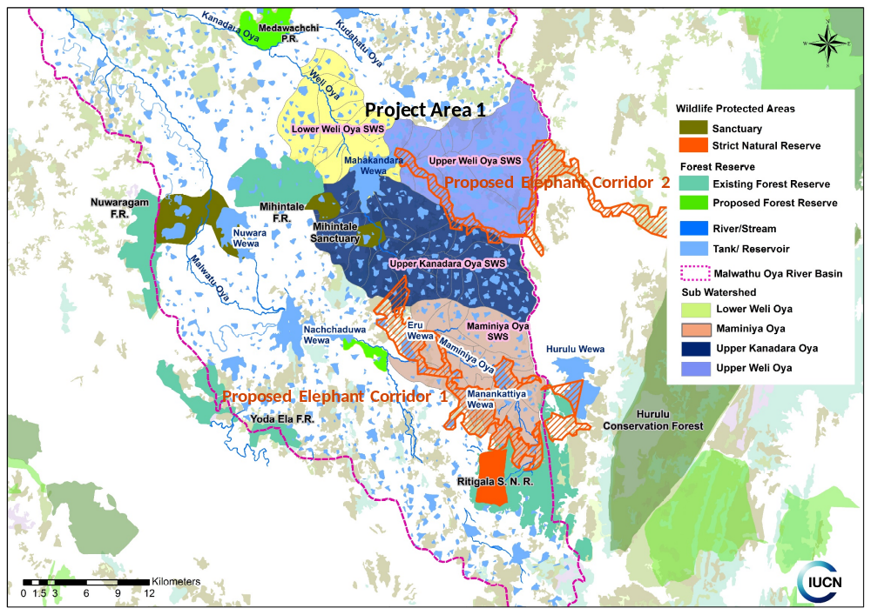
Figure 2. Two elephants corridores proposed by the Wilidlife Management Plan for the Upper Elahera Canal Project (IUCN and MMD&E, 2017) together with Eru Wewa and Manankattiya Wewa serving as stepping stones in proposed elephant corridor 1 (please note that the western sections of these corridores are yeat to be ground truthed)

Further, the need has been identified for a GIS based evaluation on land use in order to identify, (a) sites for habitat restoration, (b) degraded areas for reforestation or afforestation, (c) currently unprotected areas to be newly declared as protected as well as (c) areas to be augmented to adjacent protected areas in the existing PA network. This should be conducted as a priority activity during the early stages of the project period. Then such decisions of augmentation of protected areas can be taken at the Special Area Management decision making bodies proposed by the project for Trial Landscapes which could then be decelaired under the relevant jurisdictions.

Proposed Elephant Corridors
Two elephant corridores proposed by the Wilidlife Management Plan for the Upper Elahera Canal Project (IUCN and MMD&E, 2017; see Figure 2), based on prolonged observations by the officers of the DWC, in order to connect Hurulu Conservation Forest with the forested areas in the western Upper Malwathu Oya basin and the Kala Oya basin are the last remaining tarcks of forests, which are currently been used by the elephants for their movements. Therefore, delaration of these corridored as protected would be a prime need in elephant management in the Trial Landscape 1. Both the ongoing ESCAMP and Upper Elahera Canal Projects can co-finance this declaration [in terms of (a) radio-tracking of elephant movements in order to confirm the use of these propsed corridores by elephants and (b) for provision of fair compensation packages for families to be resettled]. Nevertheless, developing synergy between these projects would provide the last chance of protecting these narrow trackts of forests that are being subjected to illegal encrcohement at an alarming rate.
Nevertheless, only the eastern sections of these two wildlife corridores have currently been mapped through GPS locations and ground truthing (see the abrupt western ends of the corridores, which are clearly linking with the Hurulu Conservation Forest in the east). Although the Anuradhapura Assitant Directors Diivision of the DWC has condcuted some ground surveys to complete the western sections of these corridores, they are still incomplete. Therefore, the ‘MT’ project can conduct a rapid study in collabiration with the DWC to preperly map and gound truth the wstern sections of thsese two elephant corridores, during the initial stages of the project.
Furthermore, another elephant corridor has already been identified by the DWC as a necessity to facilitate uninterrupted elephant movements between the Wilpattu and Madu-Road National Parks, which falls in the Trial Landscape 2 (see Figure 3). GPS locations to delimit this elephant corridor were provided by the DWC, based on the field surveys of relvant field officers (DWC, pers. comm., 2018).
Please see the section below on broader plan for elephant corridors in the Northern Province of Sri Lanka.

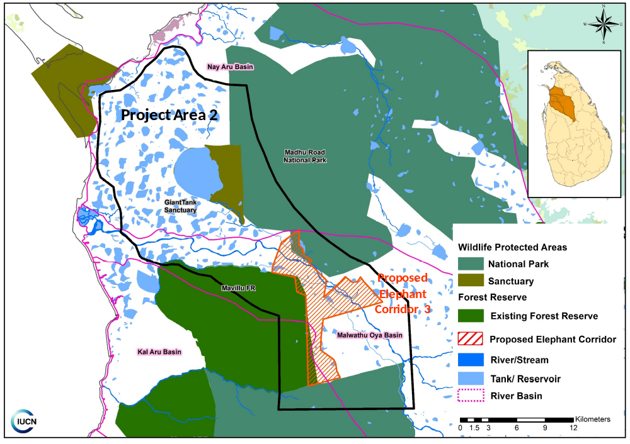
Figure 3. The elephants corridores proposed by the Wilidlife Department to link the Wilpattu and Madu Road National Parks within the Trial Landscape 2

Overall plan for elephant corridors in the northern region of Sri Lanka
When considering the landscape approach considered in designing the ‘MT’ project, there is no point in looking at elephant corridor plans in small project areas without considering the bigger picture. The elephant corridors 1,2 and 3 mapped above in figures 2 and 3 are contributing to a broad scale plan of elephant corridors for the northern region conceptualised by the DWC. Although it was not possible to provide an official map for the plans of the DWC at this point, informal discussions with various officers indicate the overall plan for northern region of the country, which is illustrated in Figure 6 (DWC. Pers. comm., 2018). The illustration is placed on the map of protected areas of Sri Lanka as of 2016 (MoMD&E, 2016).

Figure 4. A map illustrating the overall plan for elephant corridores designed for the northern region of Sri Lanka (DWC. Pers. comm.). Map of the protected areas of Sri Lanka (MoMD&E, 2016) is used as the base map.
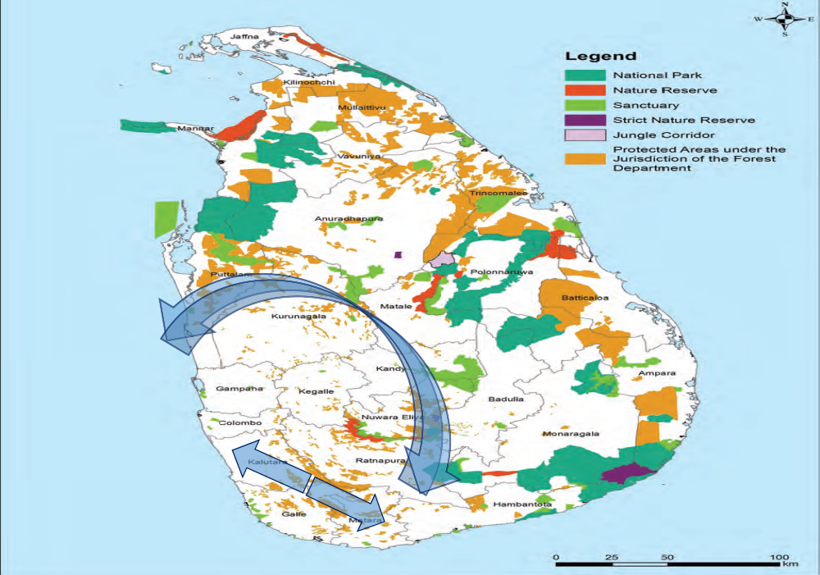

The northern section of this overall plan of the elephant corridores is also presented in a recent publication of Wijesundara et al. (2017) (see Figure 12), in which the proposed elephant corridor to link the Wilpattu and Madu Road National Parks within the Trial Landscape 2 of the ‘MT’ project is reffered by the area No 1. In addition to this major northern section, few minor active elephant corridores were also observed by the DWC field officers. This southern section is discussed in the Wildlife Management Plan of the ongoing Upper Elahera Canal Project of the Moragahakanda Irrigation Scheme (IUCN and MMD&E, 2017).

Figure 5. A map showing the proposed and recnet wildlife conservation areas of the Northern Province to confrim the proposed elephant corridor to link the Wilpattu and Madu Road National Parks reffered by No 1 (Source: Wijesundara et al., 2017)
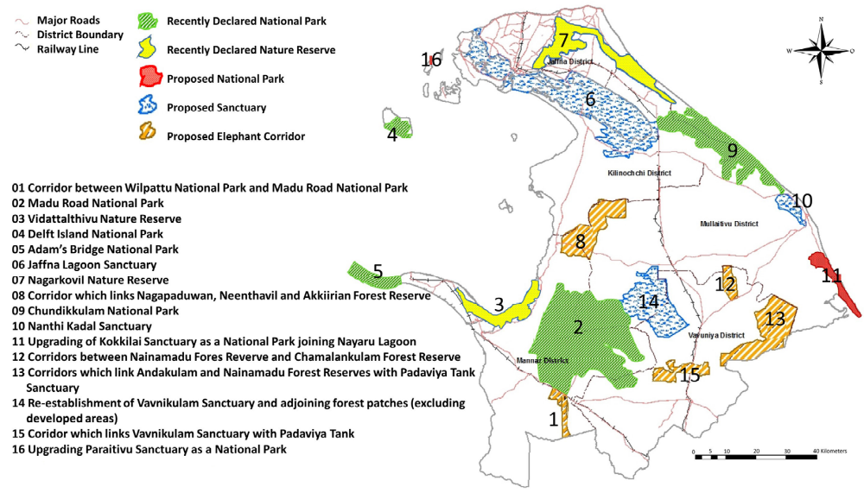

In addition to these proposals for elephant corridors in northern Sri Lanka, two other protected areas declared under the preview of the DWC are functional as active elephant corridors one in the norther and the other in southern dry zone of Sri Lanka. However, they are not named as elephant corridors due to various resource management needs pertaining to those areas. They are,
- The Kaudulla-Minneriay Jungle Corridor declared under the accelerated Mahaweli Programme by the DEC to link Minneriya National Park and the Hurulu Conservation Forest.
- Vetahirakanda Nature Reserve linking the Udawalawe and Lunugamweherea National Parks

Dugong and Seagrass Conservation Areas
The only Marine Protected Area situated in the seascape of the Gulf of Mannar is the Bar Reef Sanctuary which is located south of the Trial Landscape 3. The GEF funded project on the conservation of Dugong and sea grass beds in the Gulf of Mannar, in collaboration with the DWC and other partners have recently identified three areas of shallow sea for the protection of the dugong and conservation of seagrass meadows (Arjan Rajasuriya, Pers. Comm. 2018). Two of these areas, (1) Arippu – Silavathurai cluster which includes Vankalai coral reef and seagrass meadows, and (2) Kudiramalai – Mollikulam cluster, fall within the ‘MT’ Trial Landscape 3 (See Figure. 6).

Contribution of proposed PAs within the project landscape and designated Trial Landscapes
In summary above mentioned proposed elephant corridores accounts for and dditional protection for elephants as well as the biodiversity in general in 2.3% of that project landscape, i.e. 138km² of new protected areas when all three elephant corridores as mapped in figure 2 and 3 are put together. Additionally, the western sections of the proposed elephant corridores 2 and 3 are yet to be mapped and ground truthed. Therefore the actual amoutn of new protected areas would certainly be larger than the above figure.
The Eelphant Corridor 1 and 2 would contribute to additional protection with 9.2% of that Trial Landscape 1 (83km² together), while the elephant corridor 3 would newly protects 10% of that Trial Landscape 2 (55km²).
Similarly the two proposed dugong and seagrass conservation areas of the seascape would contribute to the protection of with 53% of the seascape of Trial Landscape 3 (465km² together)

Figure 6. Locations of the proposed dugong and seegrass conservation areas within the Trial Landscape 3 as well as other marine protected areas in the vicinity.
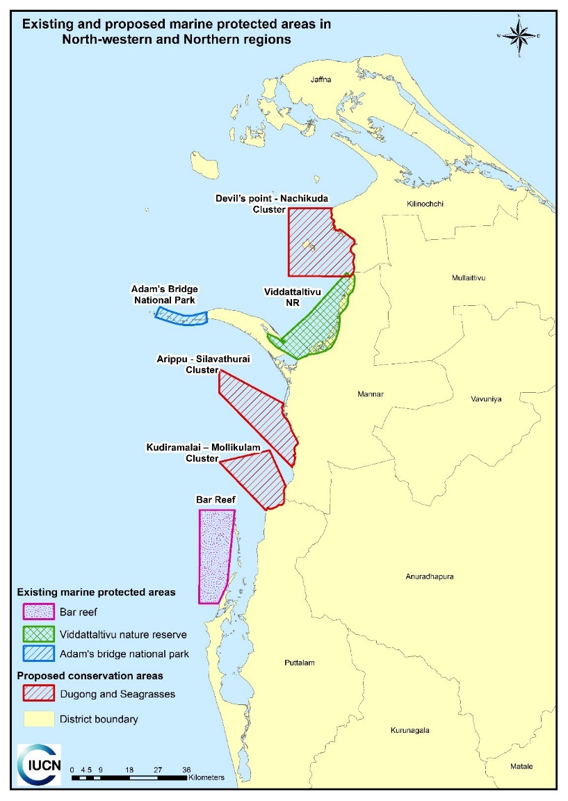

Ecologically Sensitive Areas
A potential new category of protected/managed areas will be piloted through the (Managing Together) Project, in collaboration with the GEF Environmentally Sensitive Areas Project currently under implementation in the Kala Oya basin adjacent to the Project landscape. The proposed designation is now "Ecologically Sensitive Area" (ESA) in which management conditions will be set through a co-management modality within the existing administrative system. The GEF ESA project is currently developing criteria and management modalities for ESAs.
In each of the three Trial Landscapes of the ‘MT’ project, a detailed biodiversity assessment (following the NCR methodology – Green & Gunawardena, 1997) will be carried out and the data will be applied in ESA identification protocol. Areas that meet the criteria for this new category of PA and that would provide important conservation benefits in the context of the Landscape conservation designs prepared for the Trial Landscapes will be proposed as ESAs in coordination with the GEF ESA project.

Existing Protected Area network management plans and their effectiveness
Conservation priority assessments based on species distribution patterns are scarce in Sri Lanka. One of the noteworthy assessment that took place in mid 1990s is the National Conservation Review, which did not include the North and Eastern Provinces due to the civil unrest prevailing in those areas during those days. Such a survey related to the ‘MT’ project landscape is not available in the literature. Further, the available biodiversity data on the project landscape are scarce and patchy. Therefore, the available data are not appropriate for such an assessment during the PPG phase, while the data collected from the rapid biodiversity survey is far incomplete for such a landscape wide assessment. Therefore, a protected area network management plan does not exist in the ‘MT’ project landscape.

References

DWC. (2007). Resource inventory of Wilpattu National Park. Department of Wildlife Conservation, Colombo.

Green, M.J.B. and Gunawardena, E.R.N. (1997). Designing an optimum protected areas system for Sri Lanka's natural forests. 2 volumes. Environmental Management in Forestry Developments Project, Forest Department, Government of Sri Lanka, Colombo. 399 pp.

IUCN and MMD&E (2017). The Wildlife Management Plan, including Human Elephant Conflict Management and Mitigation, for the Upper Elahera Canal Project (UECP) Colombo: IUCN and MASL. 392 pp.

MoMD&E (2016). National Biodiversity Strategic Action Plan 2016-2022. Colombo, Sri Lanka: Biodiversity Secretariat, Ministry of Mahaweli Development and Environment. xxi + 284 pp.

Wijesundara C.S., Warakagoda D., Sirivardana U., Chathuranga D., Hettiarachchi T., Perera N., Rajkumar P., Wanniarachchi S. and Weerakoon G. (2017). Diversity and Conservation of Waterbirds in the Northern Avifaunal Region of Sri Lanka. Ceylon Journal of Science 46 (Special Issue). pp 143-155.

https://www.thegef.org/project/enhancing-biodiversity-conservation-and-sustenance-ecosystem-services-environmentally

